LAB Logbook

Lab 1 – Week 1
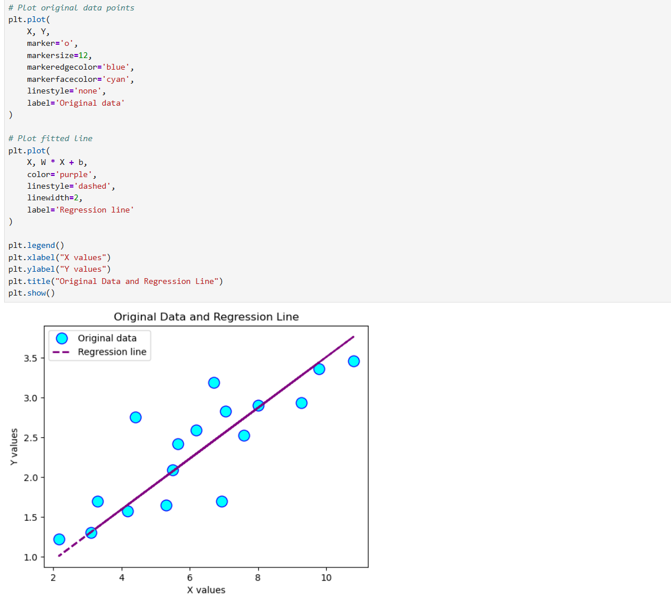

Lab 2
TASK-1
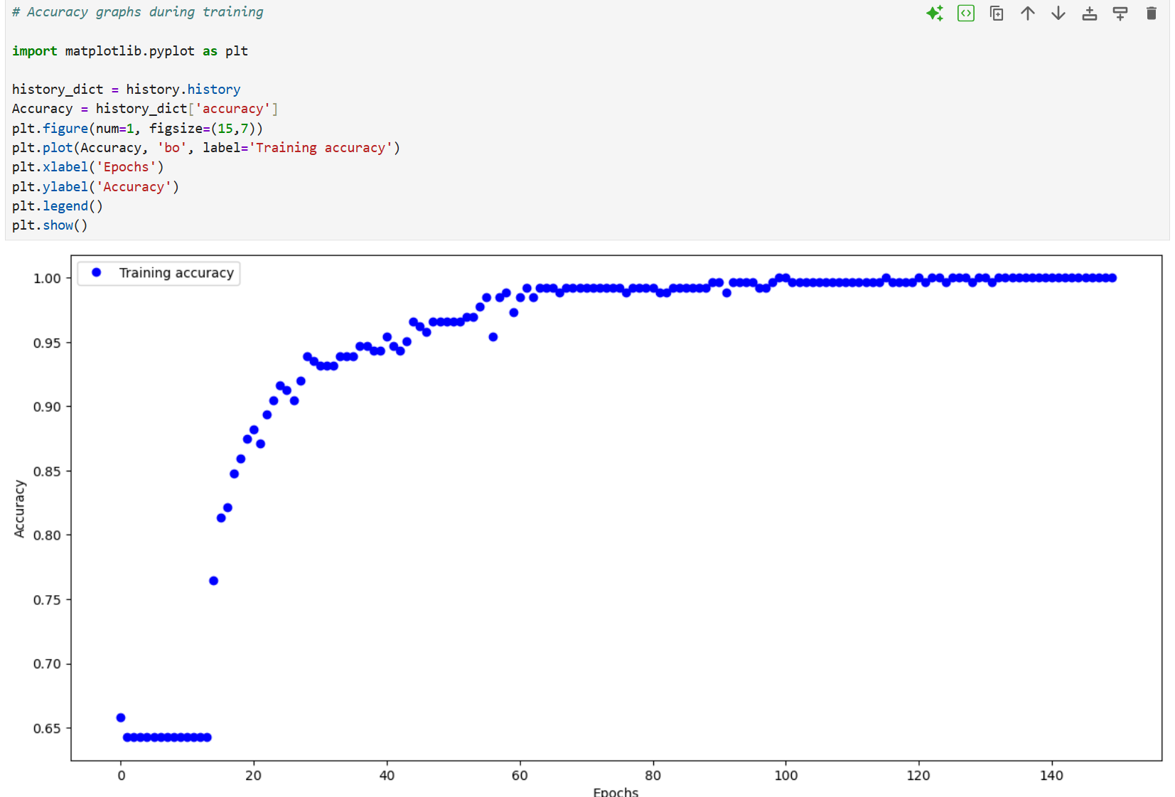
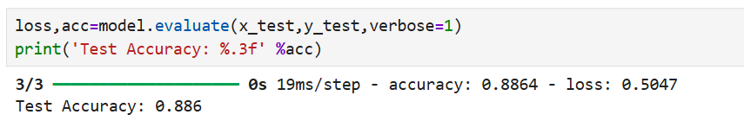

Task-2-
Output O1 = 0.99999
Output O2 =0.99964

Lab 3-
Task -1
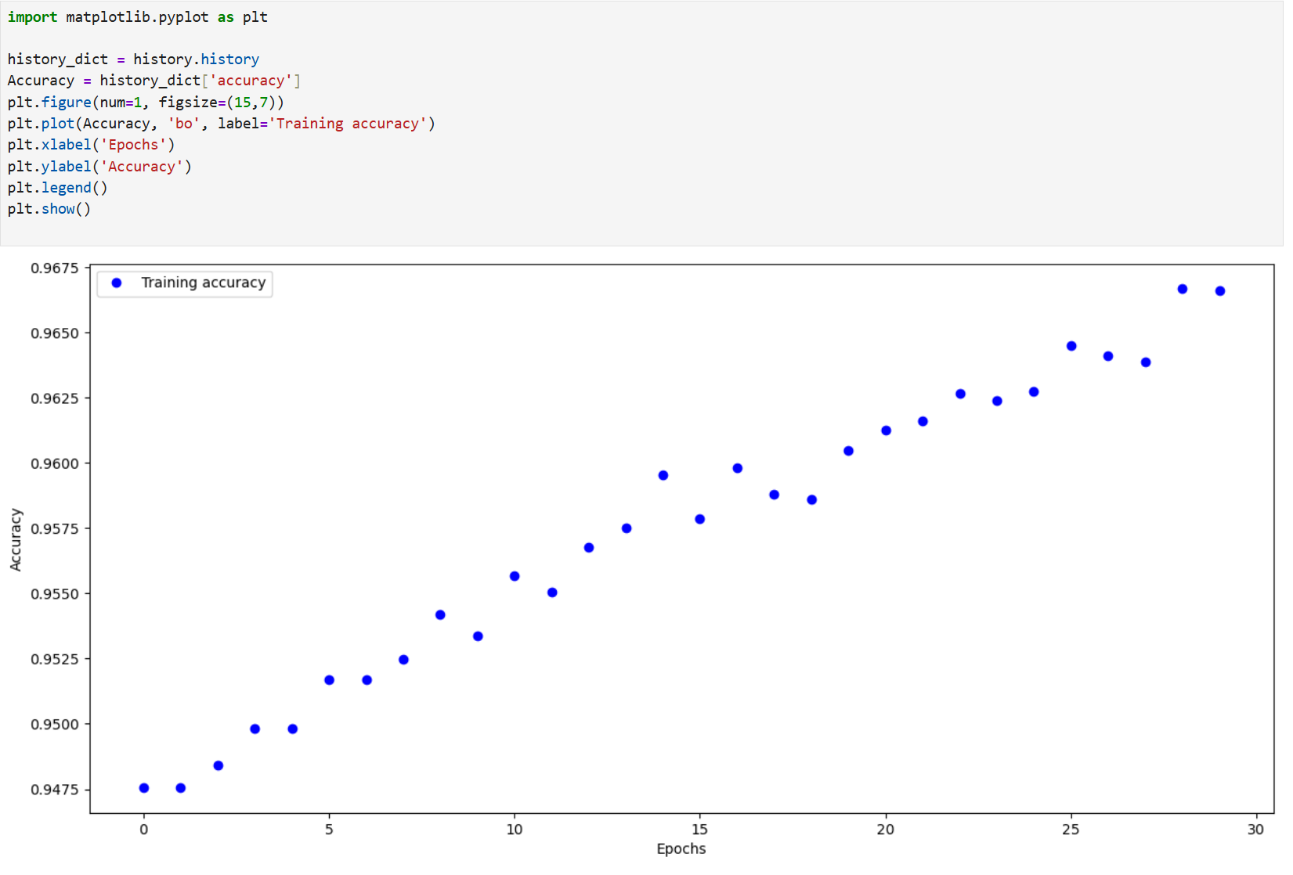
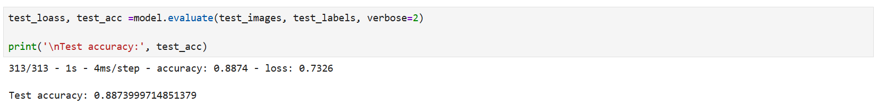
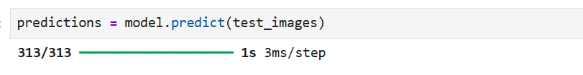

Task -2-
Lab 4-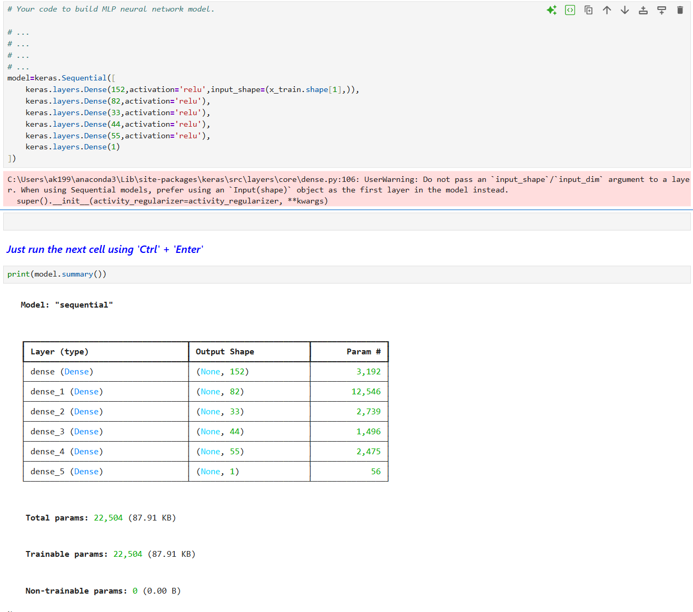
Optimizer used:
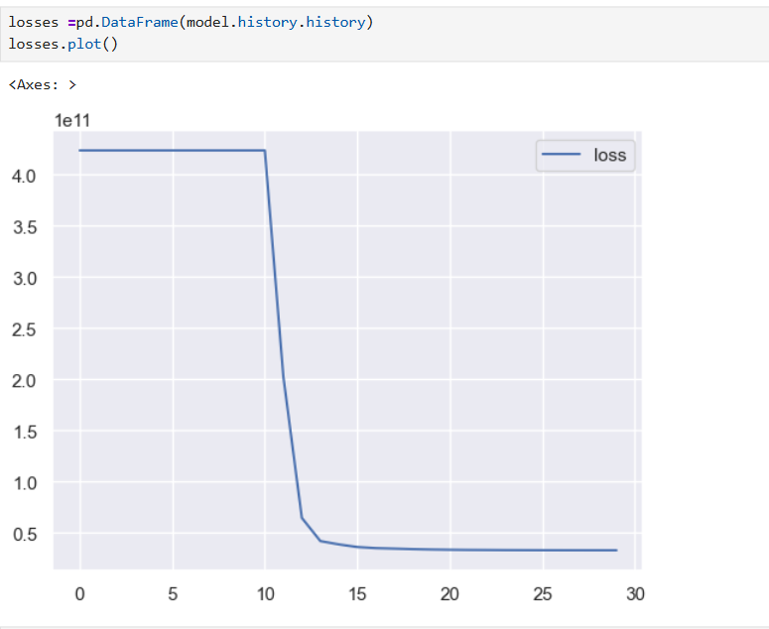
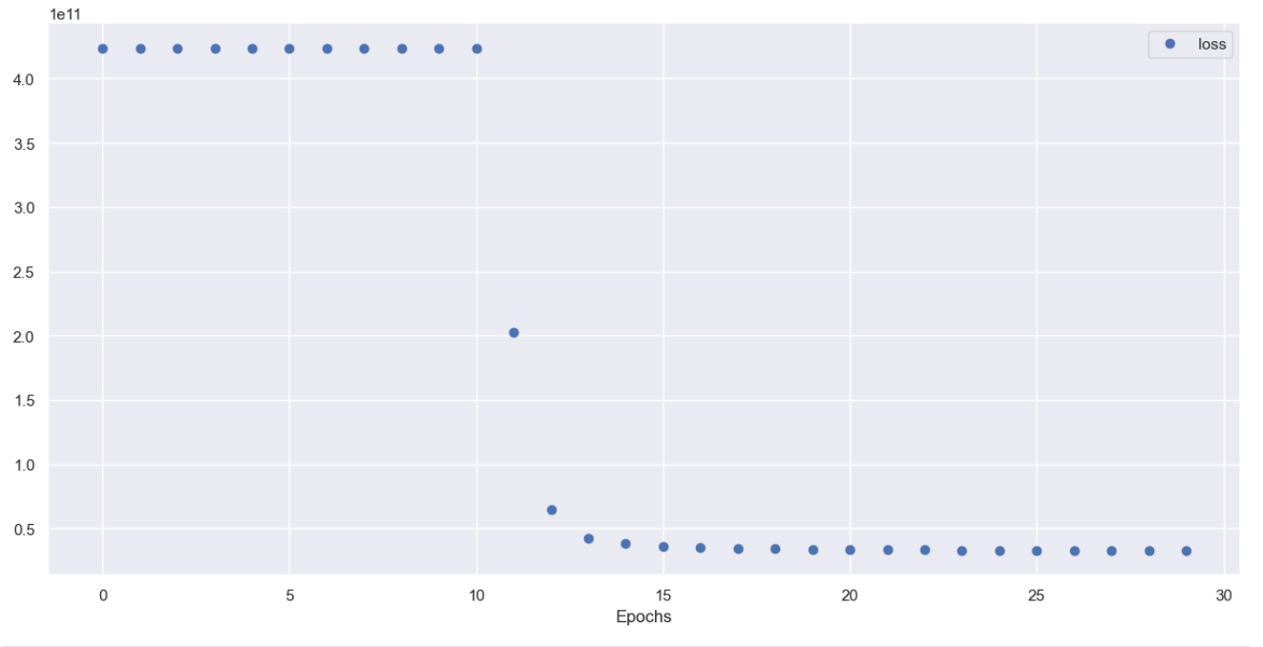
Lab 5

Lab 6

Lab 7

Lab 8

Lab 9

Lab 10

Lab 11

Lab 12

